|  |
| --- |
| Functional Specifications Document  Interior Recommendation System  Project Code:  PR_CD_29010  Internal Advisor:  Tayyba Adien  External Advisor:  Mam Daima  Project Manager:  Tayyba Adien  Project Team:  Tayyba Adien  Submission Date:  06/07/2022 _____________________ **Project Manager’s Signature** |

**Table of Contents**

1. Introduction 4

1.1 Purpose of Document 4

1.2 Project Overview 4

1.3 Scope 4

2. Functional Requirements 4

3. Non-functional Requirements 4

3.1 Performance Requirements 4

3.2 Safety Requirements 4

3.3 Security Requirements 4

3.4 User Documentation 4

4. Assumptions and Dependencies 4

5. System Architecture 5

6. Use Cases 5

6.1 Use Case Diagrams 5

6.2 Use Case Description 5

7. Graphical User Interfaces 6

8. High Level Design 6

8.1 ER Diagram 6

8.2 Data Dictionary 6

*8.2.1 Data 1 6*

*8.2.2 Data 2 6*

*8.2.3 Data n 6*

9. Requirements Traceability Matrix 7

10. Risk Analysis 8

11. Cost Estimation Sheet 8

12. References 8

13. Appendices 9

# Introduction

* 1. Purpose of Document :

Designing your room with the perfect color combination and pattern is not  as easy as we think. Let's say you are not an interior designer but you want that your space will look as you want but you don't know how to design your home with the right material and color combination. Then went to an interior designer who first takes a detailed interview of you and your requirements  to get to a point to understand and to find out and for getting an idea of what kind of design you want. Then after finalizing the color combination you get through 3D modeling of your house where the Designer first Designs  your interior and after a lot of variation you final finalize that you want such a design. 3D modeling itself is a lengthy procedure and by chance, if you are a confused customer and do not easily get satisfied in one go then this procedure will going to take a long time. So the solution for all the confusion is to design an app that will take your requirements are will show you previously built or new designs that are uploaded by someone Professional designer seller. This app provides you to enter your details and will show you the design according to your mood, space, color combination, material, patterns, and budget.

* 1. Project Overview:

Interior Recommendation System is an Android app that allows users to enter their interior requirements and then the system will suggest different designs for home interior and walls.

**Objectives:**

* Translate the client’s idea and professional holistic vision.
* Recommend interior design based on requirement style desire.
* The app will track user interest.
* The user will save the design to the idea book.
* Provide a guide and educate users about interior design.
* Users can contact the seller for further guidance.
* Provide interior designers to get local clients online.
* Interior designers will be able to configure clients' style desires without 3D modeling.

**Project Goal:**

                      Recommending users the most efficient layout to make the most of a room's potential in terms of use and aesthetics while taking into account the

characteristics of the space and the style desired.

**Project Success criteria**:

                              The user will log in to the system fill out the requirements form, and get an interior design recommendation. The Interior designers will upload interior designs and will get local clients online.

* 1. Scope :

The domestic decoration market economy scale has exceeded 4 trillion yuan. The number of home decoration consumers is huge, but the proportion of online shopping in the total consumption of the home decoration market is relatively small. Interior Design Recommendation app record the behavior logs of the user. The main task of this app is how to automatically locate and push the home decoration scheme that users are interested in from the massive information. By comprehensively analyzing the user’s historical behavior and item label information, the app uses a Collaborative filtering algorithm to find the best item list for users. The app will allow the users to store filtered data on idea-book, contact sellers, and guides related to interior design.

       App provides idea recommendation and selection without the use of 3D modeling. It only provides seller contact but not payment and commerce features.

1. Overall System Description
   1. User characteristics

A target audience can be anyone – But most likely this application will assist the following individuals

* People who have just purchased a new home
* People who are redecorating their home
* People who are looking for a gift for someone else
* People who need to walls design, pattern, and material without the need of interior designer
* People who are looking for a particular style
* People looking for inspiration
* Interior Designer owner who wants to display its project online
* Professional Designer who want to get style desire of its client
* Store owner who wants to get local clients online

**3 .Hardware Specification-**

* System: HpEliteBook 820  core i5
* Processor: Intel Pentium IV 1.7 to 2.9 GHz
* System type: 32-bit Operating System
* RAM: 8 Gb or higher
* HDD: Storage size 550 GB
* SSD: 256 GB

**4. SoftWare Specification-**

**Operating System**

Windows 10 pro-Linux (Manjaro KDE Plasma)

**OS for Mobile application:**

Android Mobiles

**Tools:**

* **For Development :**

Android Studio, Vs Code, IntelliJ Idea

* **For UI Designing tool:**

Adobe Xd, Figma

* **For UML Diagrams Creation:**

EdrawMax,Draw.io

**Technology used**

* **FrontEnd:**

Kotlin, Java, XML

* **Backend:**

JavaScript, Node.Js, FireBase, MongoDB

**5. System constraints**

Interior Designing app has a limitation of paid software resources like buying premium hosting for keeping and maintaining database objects and records. Also, the premium plugins that are required for adding extra functionality in IDEs to code professional. The Interior app will only operate on android mobile API levels greater than 23.

* **Hardware constraints*:***

*The Hardware on which this System is going to operate on the client-side is basically on android devices and screen size may vary from different devices which must have built-in internet and wifi connection, suitable storage size, and RAM greater than 2GB.*

* **Cultural constaints**

*The built-in cultural constraint involved in this app will be set according to demographic context because culture and choices will vary from city to city. Let's suppose the interior choices of the people who lived in Panjab will vary from the e interior choices of people who lived in Baluchistan. Because every province has its own culture which will be filtered according to people's desires and needs.*

* **Legal constraints**

*Admin are not allowed to post which not lied in the domain of interior design.Personal2 information is not allowed to share in the description of the product.*

* **Environmental constraints**

*Numerous environmental boundaries will retard the app, like avoiding it to use in noise and heat-lightening places.*

* **User constraints**

*Users are involved in interior designer customers and professional interior designers so according to the user's domain the user interface for an interior app should be more graphic and textual according to needs.*

6. External Interface Requirements

The application will be implemented in Kotlin and java it will use Android SDK. Moreover. Android Studio will be used as IDE while implementing.

Diagram will show you the interaction between the external components of the system

.

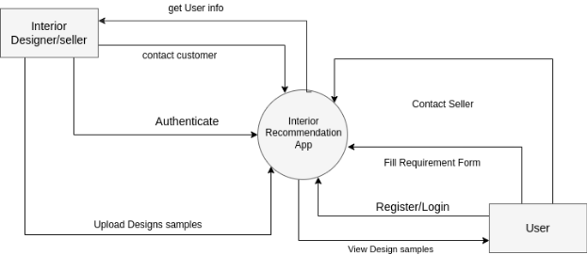

**6.1 Hardware Interfaces**

This application works on Android mobile devices and tablets. No other hardware is required.Since the application must run over the internet, all the hardware shall require to connect internet will be the hardware interface for the system. E.g. Modem, WAN – LAN, Ethernet Cross-Cable.

6.2 Software Interfaces

Interior recommendation app will first collect user requirements and style desires which will store in the database and their filtering algorithm will select and choose design samples according to user info.  Since this application is a mobile application, it will only need an Android version 4.0 or higher to perform

# 7. Functional Requirements

This subsection contains the requirements for the interior app recommendation System

* Register
* Login
* User will be able to put his design requirement according to his style desire and home specification
* System will recommend user Design sample according to user information
* User can see Samples Details
* Provide comprehensive product details.
* The system shall display detailed information about the selected products.
* The system shall provide browsing options to see product details.
* The system shall display detailed product categorization to the user.
* Provide a Search facility.
* Provide Customer Support
* User can contact Seller
* Designer/Seller will upload design samples
* Designer will upload Sample Details
* Designer will get Local clients online

# 8.Non-functional Requirements

8.1 Performance Requirements

The product shall be based on a web application and has to be run from a web server Data-base.The app shall take initial load time depending on internet connection strength which also depends on the media from which the system is run.The performance shall depend upon the hardware components of the client/customer.

8.2 Safety Requirements

Potentially is no danger concern related to this app. But let's suppose the designer accidentally put some confidential and sensitive information in product details and descriptions then any malicious user can take advantage of that so it's only allowed that the seller is restricted to upload descriptions with predefined constraints.

8.3 Security Requirements

***Customer Confidentiality*** *- The system shall not reveal any personal data related to usage scenarios or statistics.*

***Development Access*** *- All development work shall be password-protected at or above the standards.*

# 9.Assumptions and Dependencies

**Assumption:**

* The person who uses this application has an android phone.
* Is that person having any knowledge about mobile services?

**Risks:**

* Person can use the phone for the wrong purpose.
* Any person is using your application just for fun..

**Obstacles:**

* Phone services should be available.
* The phone should be connected to the internet.

# 10 .System Architecture

The Interior Design Recommendation System contains many components that provide different functionality. The below are the overall system diagram that we will discuss in further

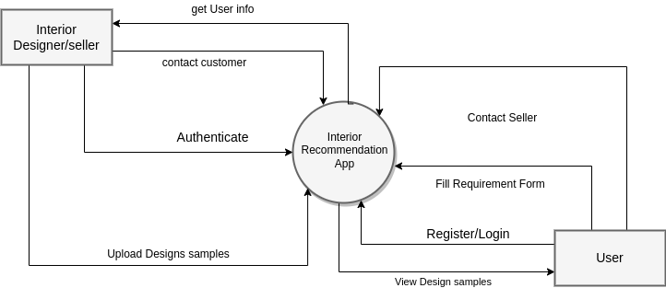

.

10.1 System Level Architecture

The Interior Design Recommendation System contains many components that provide different functionalities. The below are the overall system diagram that we will discuss in further.

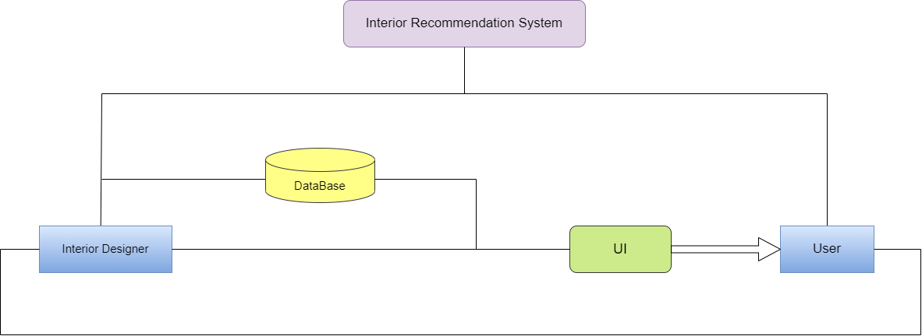

10.2 Sub-System / Component / Module Level Architecture

* **Interior Designer:**

In this panel Interior Designer interact with UI to perform operations related to add , delete , edit and manage sample design .Admin will update a data time to time.

* **User:**

In this panel user interact with UI to perform operations related to Fill requirement

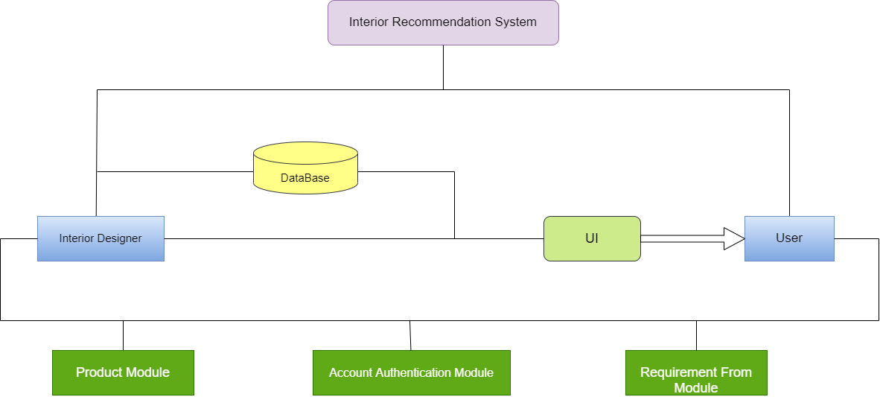

10. 3 . Sub-Component / Sub-Module Level Architecture (1…n)

Database:

Database will store the data related to user , interior designer , requirement from ,and sample design .So , in case of data lose user/interior designer will recover it from database.

Product module :

This module consist on

**Sample Design:**

In this we will store data related to product image , title , description etc

**Search design:**

Interior designer will search design related to his requirement.

Account authentication Module:

This module consist on

User / Interior Designer Registration

User will put its info related to registration information such as email and password

Login:

User will match his credential in this module

Requirement Form Module:

This module consist on

**Enter Details:**

This module will get info form user in the from of requirements

**View Recommendation:**

User will get recommendation from system int e form of requirements.

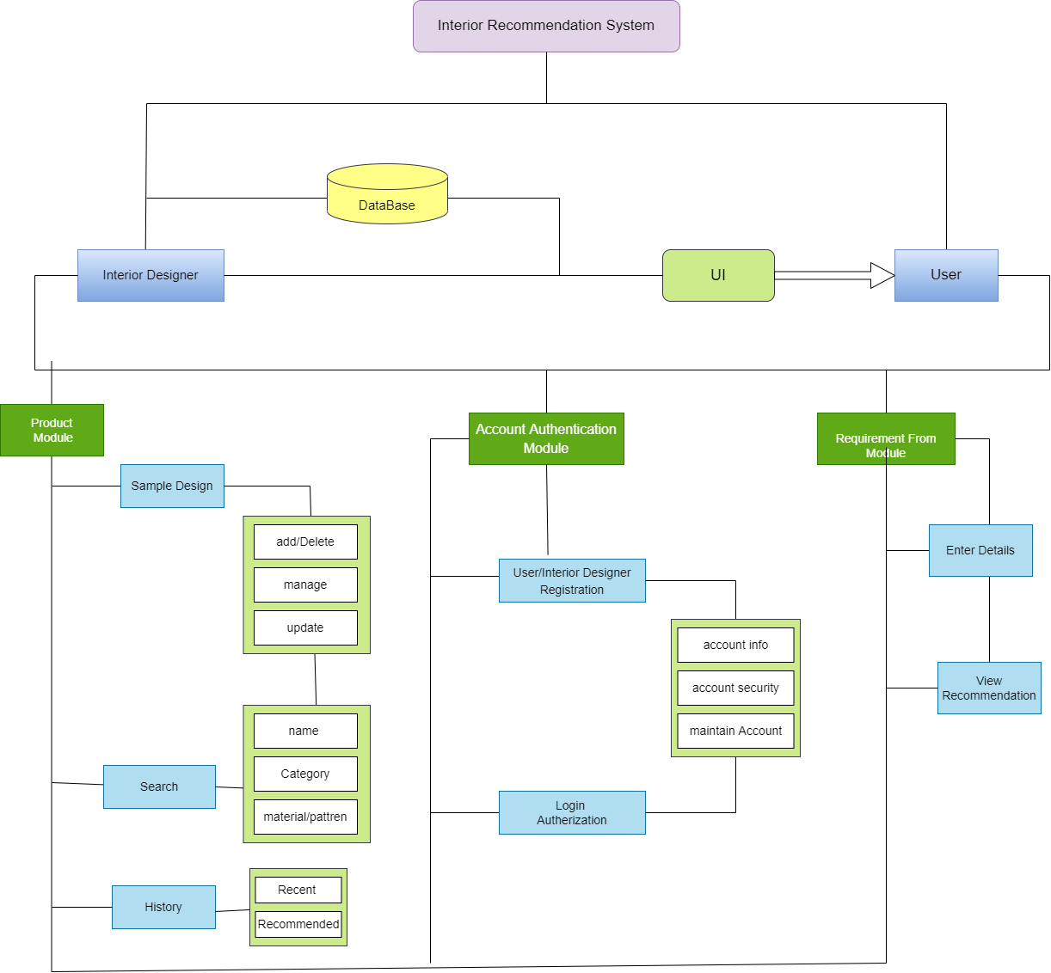

# 11.Design Strategies

Our application consist on tracking user behavior and queries

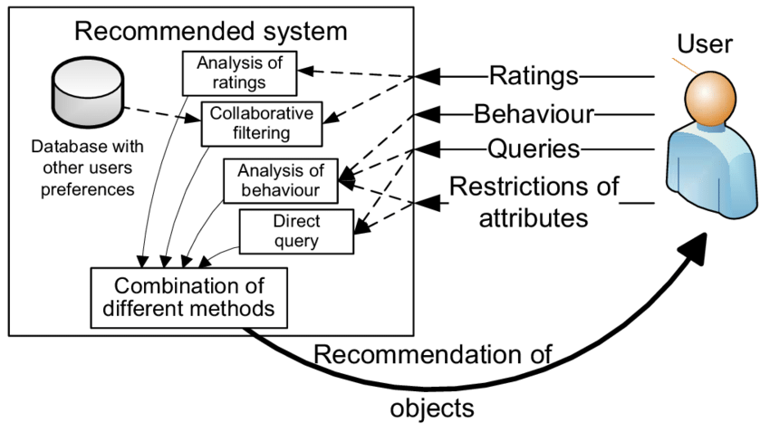

11.2 Strategy 1…n

The designing Stratgy will be based on recommendation in which system will tract the user behavior queries to configure the user taste and desire and after that that data will goes to database through which design will be filtered according to attributes given.

# 12. Detailed System Design

**12 .1 Class Diagram**

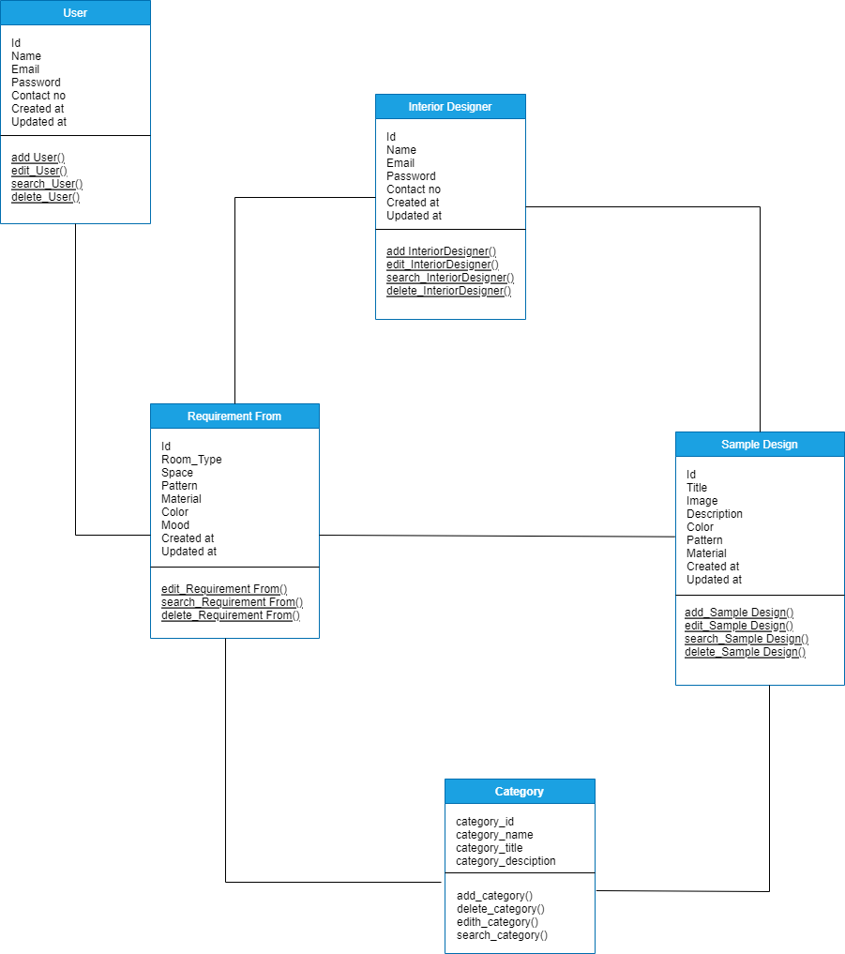

**User Class**

ID: this is the unique identifier of each user

Name: the name of the user

Password: the password of the user

Email: the email id of the user

Contact no : this is the phone no of user

**Interior Designer Class**

ID: this is the unique identifier of Interior Designer

Name: the name of the Interior Designer

Password: the password of the Interior Designer

Email: the email id of the Interior Designer

Contact no : this is the phone no of Interior Designer

**Design Sample Class**

ID: this is the unique identifier of Design Sample

Title: the title of Design Sample

Image: the image of sample Design

Description : the description of sample Design

Color : the color of sample Design

Material: the Material of sample Design

Pattern: the pattern of sample Design

**Requirement Form Class**

ID: this is the unique identifier of Requirement Form

Title : the title of Requirement Form

Image: the image of Requirement Form

mood : the mood of Requirement Form

Color : the the color of Requirement Form

Material: the Material of Requirement Form

Pattern: the pattern of Requirement Form

**Category Class**

ID : this is the unique identifier of Category

Name : this is the Name of Category

Title : this is the unique Title of Category

Description : this is the Description identifier of Category

# 12 .2 State Transition Diagram

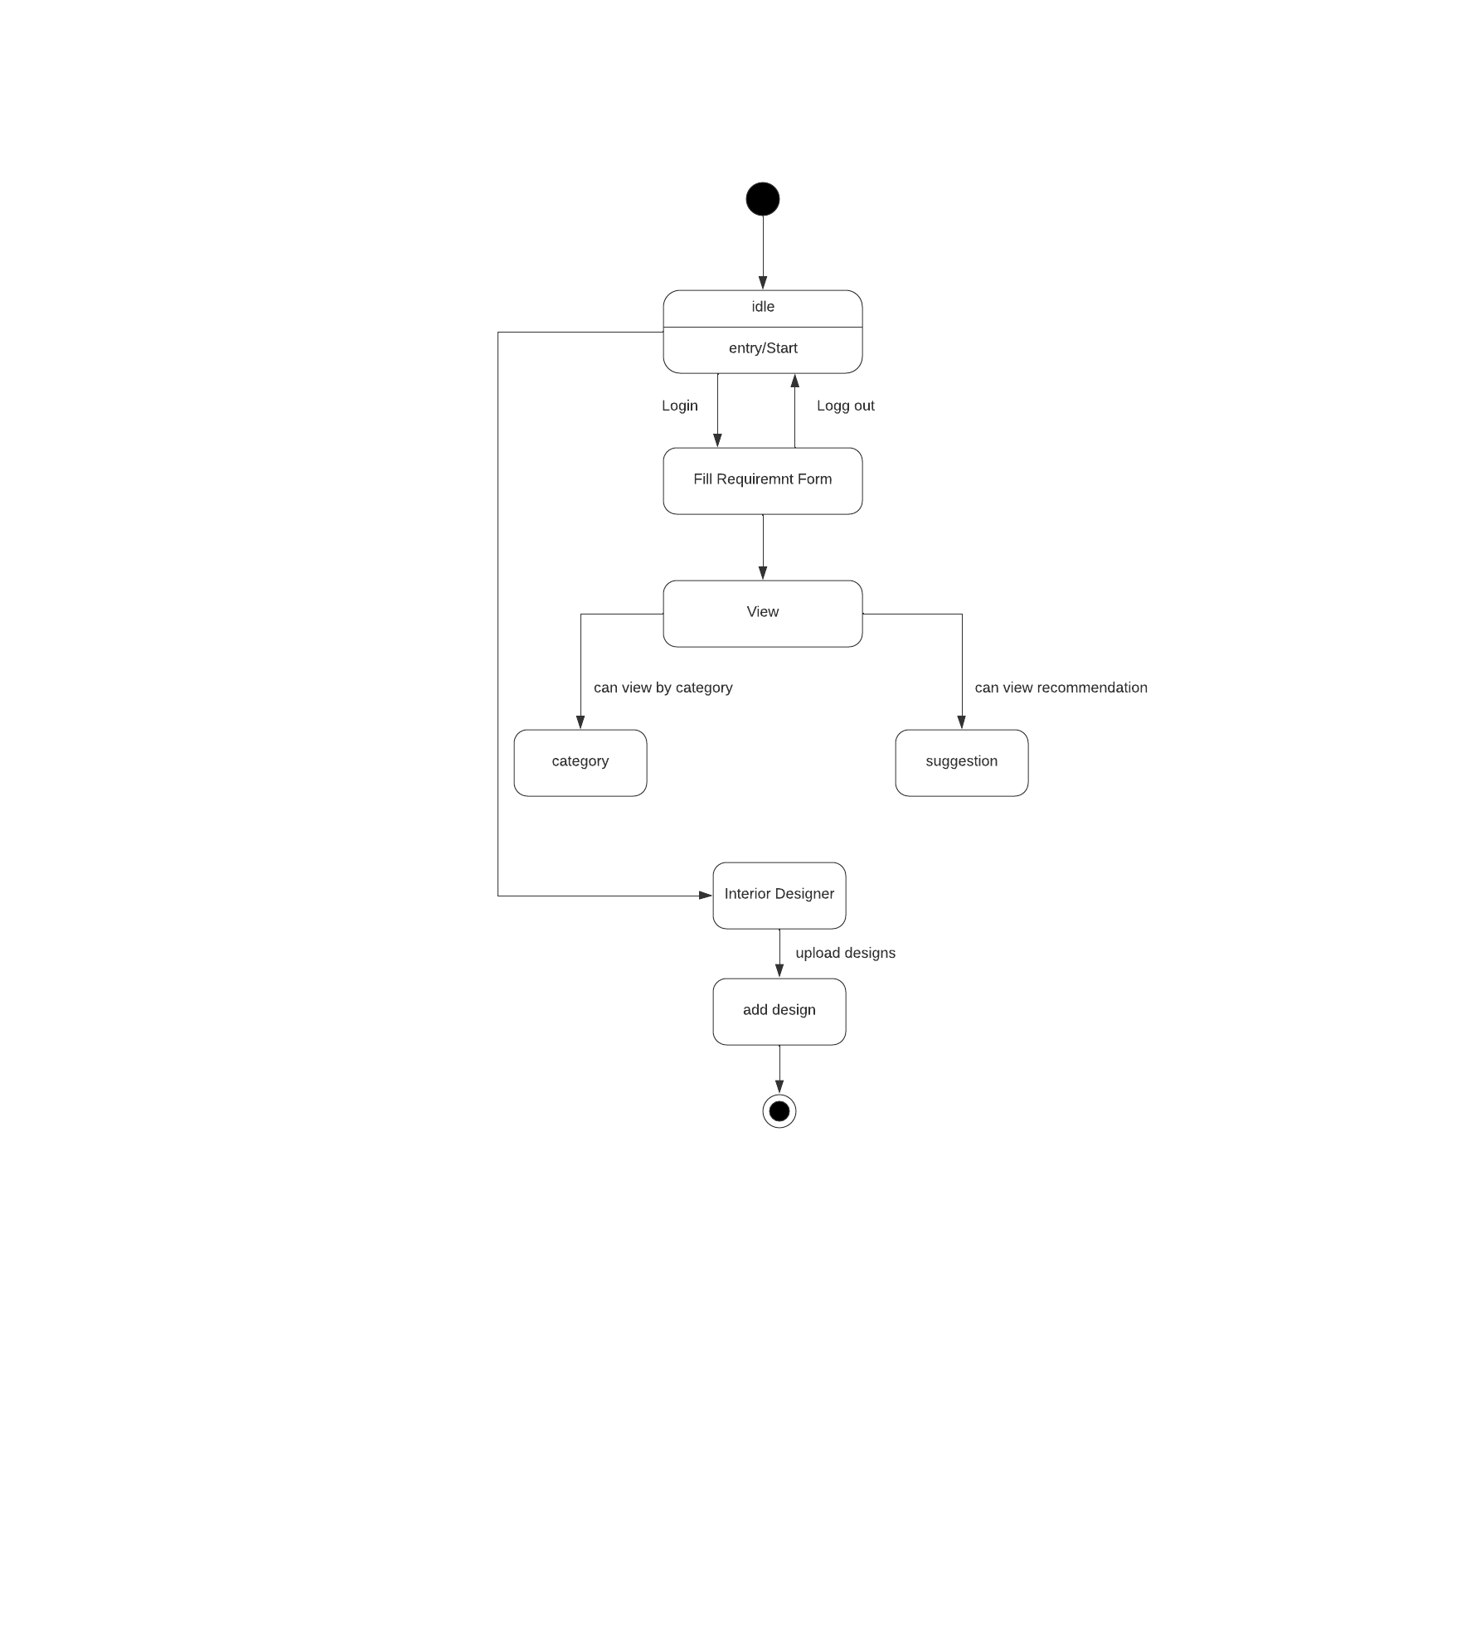

# 12 .3 Sequence Diagram:

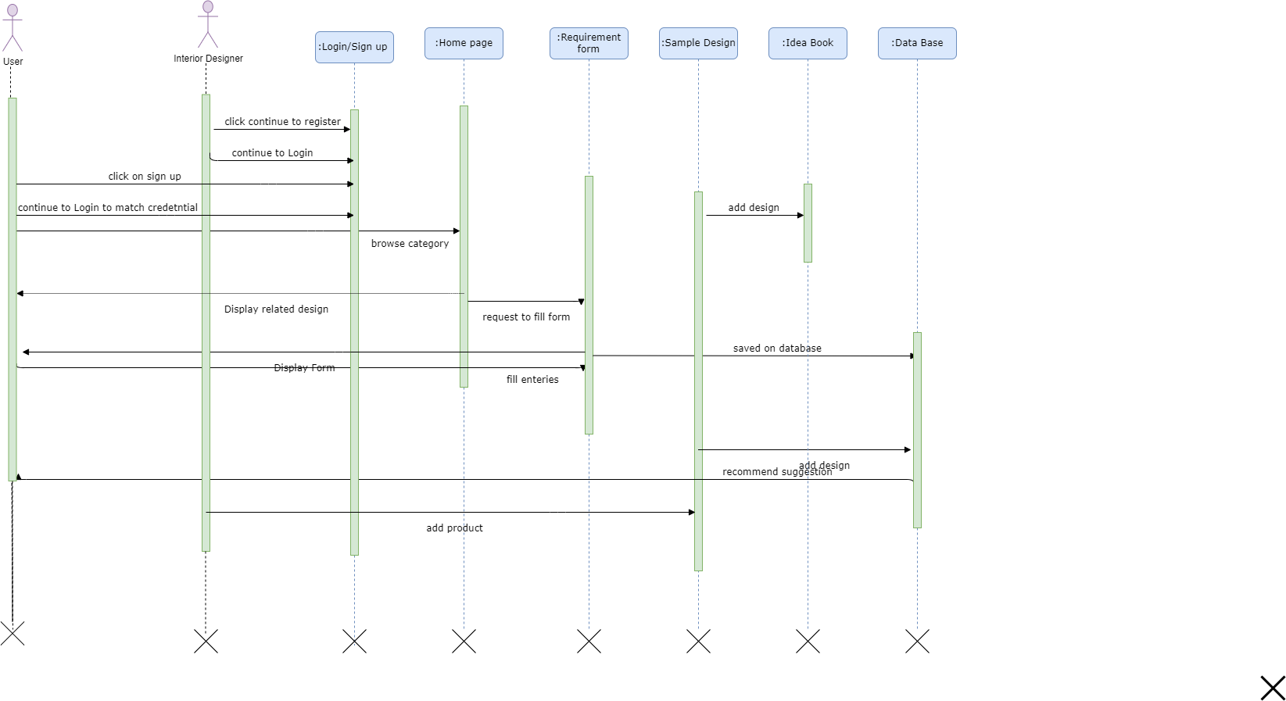

12 .4Use Case Diagrams

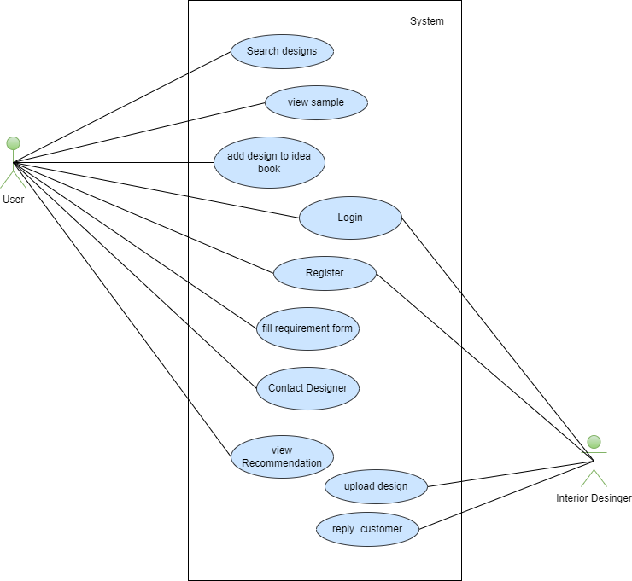

12.4.1 Use Case Description

|  |  |  |  |  |
| --- | --- | --- | --- | --- |
| **Use Case UC1: Interior Recommendation System** | | | | |
| **Actors:**  user , Interior Designer | | | | |
| **Feature:** *User will search for design and Interior designer will guide customer* | | | | |
| **Use case Id:** | | *UC1* | | |
| **Pre-condition:** | | User and Designer are identified and authenticated | | |
| **Scenarios** | | | | |
| **Step#** | **Action** | | | **Software Reaction** |
| **1** | *Login* | | | *Application will send credential to database to match the email and password* |
| **2** | Registration | | | Send user data to Database to add a user |
| **3** | View Suggestion | | | System will filter design suggestion based on user requirement criteria |
| **4** | Fill Recommendation | | | Store and process the info |
| **5** | Contact Interior Designer | | | System will direct the user to chats area |
| **6** | Add/Delete Design | | | System will add and delete products from database |
| **Alternate Scenarios:** *.* | | | | |
| **1a: At any time system fails,**  To support recovery system,ensure that system will persist sensitive state and events can be recovered  **2a: At any Time user will forgot his id,**  System should provide the mechanism to recover his account | | | | |
| **Post Conditions** | | | | |
| **Step#** | **Description** | | | |
| **1** | *User successfully logged in* | | | |
| **2** | Change made by admin will store on the database and retrieved when require | | | |
| **User Interface reference** | | | *List user interface(s) that are related to this use case. Use numbered list in case of more than one user interface elements.* | |
| **Concurrency and Response**   * ***2 users(customer and Interior Designer*** * ***Expected response Time 10 sec*** | | | | |

# 13 . Graphical User Interfaces

|  |  |
| --- | --- |
| **<1: Welcome Screen>** | |
| **Interface Id.** | *1* |
| **Use case Reference** | *UC1* |
| **Snapshot** | |
|  | |
|  | |

|  |  |
| --- | --- |
| **<2: Login/Sign Up>** | |
| **Interface Id.** | *2* |
| **Use case Reference** | *UC1* |
| **Snapshot** | |
|  | |
|  | |

|  |  |
| --- | --- |
| **<3: Home Screen>** | |
| **Interface Id.** | *3* |
| **Use case Reference** | *UC1* |
| **Snapshot** | |
|  | |
|  | |

|  |  |
| --- | --- |
| **<4:Sample Design Page>** | |
| **Interface Id.** | *4* |
| **Use case Reference** | *UC1* |
| **Snapshot** | |
|  | |
|  | |

|  |  |
| --- | --- |
| **<5:Requirement Form>** | |
| **Interface Id.** | *5* |
| **Use case Reference** | *UC1* |
| **Snapshot** | |
|  | |
|  | |

# 14 .High Level Design

**14.1 ER Diagram**

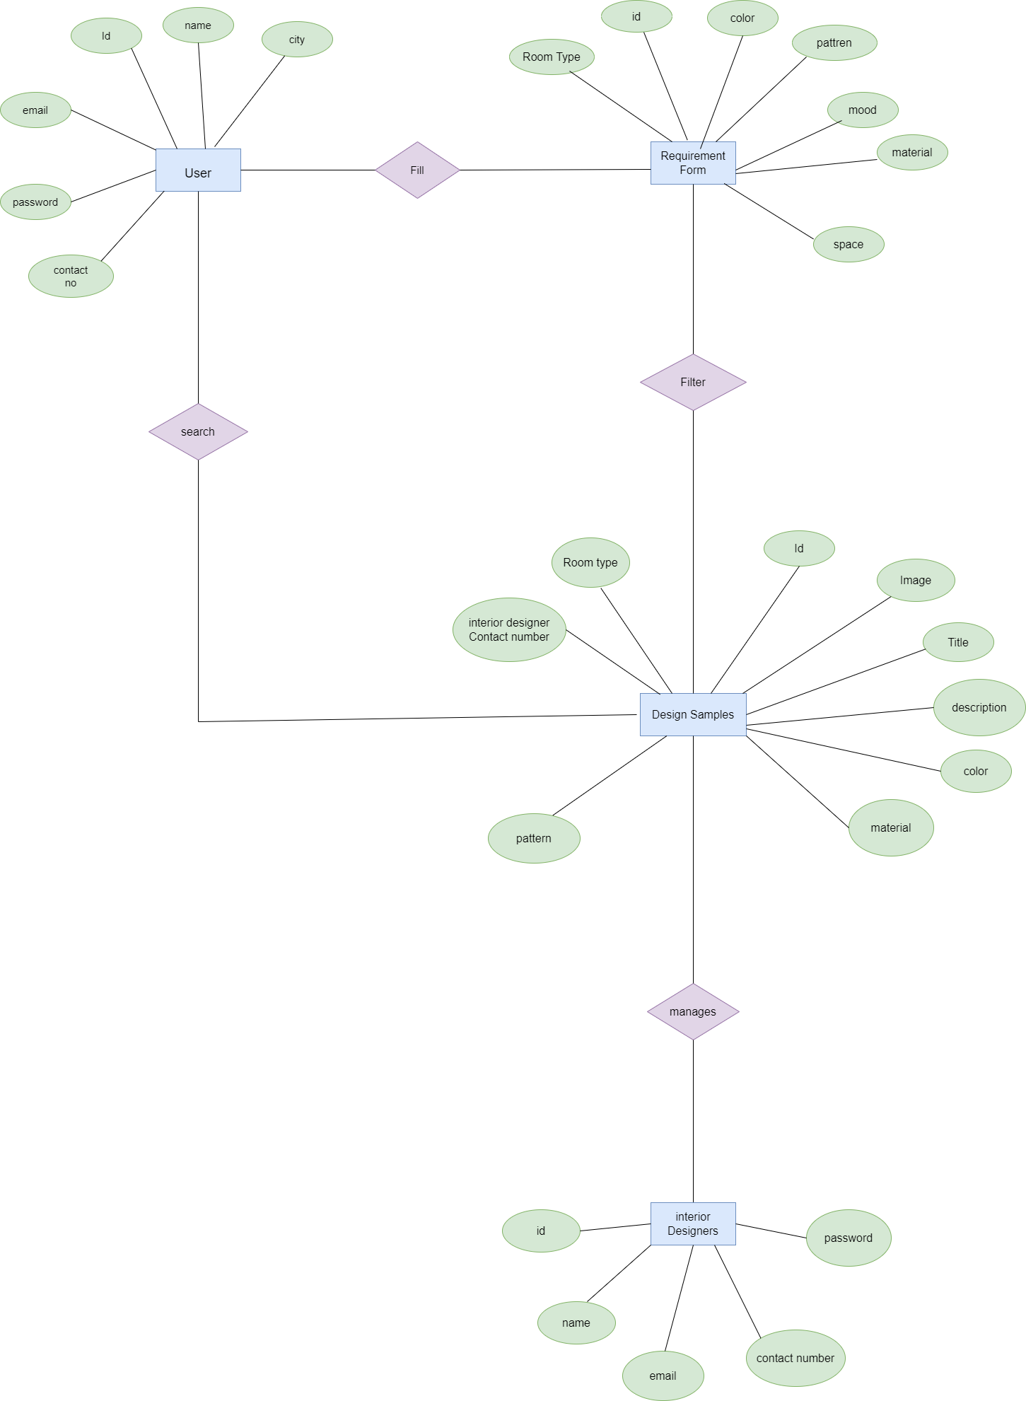

15 .Data Dictionary

A Data Dictionary is a collection of names, definitions, and attributes about data elements that are being used or captured in a database, information system, or part of a research projec**t**.

15 .1 Data 1

|  |  |
| --- | --- |
| **< Data 1>** | |
| Name | *User* |
| ***Alias*** | *Id, name , email , password , contact no, city* |
| ***Where-used/how-used*** | *Data will be stored in User table in Database using user regeneration form , as an output of this process user account will be created ,and user will login by matching credentials* |
| *Content description* | *It consist on User database table fields* |
| ***Supplementary information*** | *DataType will be varchar , with fixed length 256* |

15.2 Data 2

|  |  |
| --- | --- |
| **< Data 2>** | |
| Name | *Requirements Form* |
| ***Alias*** | *Id, color , mode ,material , space , pattern , Room Type* |
| ***Where-used/how-used*** | *Data will be stored in Requirement Form table in Database ,which will store user requirement about interior design , using this data application will filter sample data to recommend it to the user* |
| *Content description* | *It consist on Requirement form database table fields* |
| ***Supplementary information*** | *DataType will be varchar , with fixed length 256* |

15 .3 Data 3

|  |  |
| --- | --- |
| **< Data 3>** | |
| Name | *Interior Designer* |
| ***Alias*** | *Id, name , email , password , contact no, city* |
| ***Where-used/how-used*** | *Data will be stored in Interior Designer table in Database using user regeneration form , as an output of this process Interior account will be created ,and user will login by matching credentials* |
| *Content description* | *It consist on Interior Designer database table fields* |
| ***Supplementary information*** | *DataType will be varchar , with fixed length 256* |

15 . 4 Data 4

|  |  |
| --- | --- |
| **< Data 4>** | |
| Name | *Sample Design* |
| ***Alias*** | *Id, image , description , color , pattern , material , designer contact number* |
| ***Where-used/how-used*** | *Data will be stored in Sample Deign table in Database use to display design in on app* |
| *Content description* | *It consist on User database table fields* |
| ***Supplementary information*** | *DataType will be varchar , with fixed length 256* |

# 16 . Requirements Traceability Matrix

|  |  |  |  |  |  |  |
| --- | --- | --- | --- | --- | --- | --- |
| **Sr#** | **Feature** | **Use case ID** | **UI ID** | **Priority** | **Build Number** | **Use Case Cross reference** |
| 1 | Login/Sign Up | UC_1 | 1 | 2 | BN_1 | UC_! |
| 2 | Home | UC_1 | 2 | 1 | BN_2 | UC_1 |
| .3 | Sample Design | UC_1 | 3 | 1 | BN_3 | UC_1 |
| .4 | Req Form | UC_1 | 4 | 3 | BN_4 | UC_1 |

# 17 . Risk Analysis

## 17 .1 Risk Tables

|  |  |
| --- | --- |
| **RISK ID#** | **RISK NAME** |
| RS1 | Requirement incompleteness |
| RS2 | Time consuming |
| RS3 | Data insecurity |
| RS5 | Performance risk |

#### Risk no 1:

|  |  |  |  |
| --- | --- | --- | --- |
| **RISK RECORD** | | | |
| Risk ID | **RS1** | Risk Title | **Requirement Incompleteness** |
| Owner | Requirement  Team | Status | Potential |
| **Risk Description:** Requirement team has not experienced to consider all  aspects of whole system, due to this risk some requirement may be oversight and ambiguous. | | | |

|  |  |  |  |  |
| --- | --- | --- | --- | --- |
| **Impact Description:** Incompleteness of requirements will lead us to more issues in whole process. | | | | |
| **Probability/Impact Value:** | | | | |
|  | Probability | Impact | | |
| Cost | Duration | Quality |
| Pre-mitigation | 0.70 | 0.20 | 0.40 | 0.40 |
| Post-mitigation | 0.50 | 0.10 | 0.20 | 0.80 |

* **Risk no 2:**

|  |  |  |  |  |  |  |  |
| --- | --- | --- | --- | --- | --- | --- | --- |
| **RISK RECORD** | | | | | | | |
| Risk ID | RS2 | | Risk Title | | Time consuming | | |
| Owner | Un  experienced person | | Status | | Potential | | |
| **Risk Description:** Users has not experienced to consider all aspects of whole system, due to this risk more time is spend on this process such as making  different type of reports. | | | | | | | |
| **Impact Description:** Much waste of time will lead us to more issues in whole process. Dissatisfaction of client, lack of interest . | | | | | | | |
| **Probability/Impact Value:** | | | | | | | |
|  | | Probability | | Impact | | | |
| Cost | | Duration | Quality |
| Pre-mitigation | | 0.50 | | 0.20 | | 0.40 | 0.80 |
| Post-mitigation | | 0.70 | | 0.10 | | 0.20 | 0.40 |

#### Risk no 3:

|  |  |  |  |  |  |  |  |
| --- | --- | --- | --- | --- | --- | --- | --- |
| **RISK RECORD** | | | | | | | |
| **Risk ID** | RS4 | | Risk Title | | **Performance risk** | | |
| Owner | Un  experienced users | | Status | | Potential | | |
| **Risk Description:** When our project performance is not good and it does not respons in a better way then no one like it and show their interest about this. | | | | | | | |
| **Impact Description:** Very bad performance of the project leads to very big loss  and it does not fulfill the user’s requirements . | | | | | | | |
| **Probability/Impact Value:** | | | | | | | |
|  | | Probability | | Impact | | | |
| Cost | | Duration | Quality |
| Pre-mitigation | | 0.70 | | 0.20 | | 0.40 | 0.40 |
| Post-mitigation | | 0.90 | | 0.10 | | 0.20 | 0.80 |

# Cost Estimation Sheet

|  |  |  |
| --- | --- | --- |
| **1.** | **Software cost** | 500$ |
| **2.** | **Package Software** | 100$ |
| **3.** | **Hardware** | 300$ |
| **4.** | **Network** | 100$ |
| **5.** | **Client** | 200$ |
| **6.** | **Misc** |  |
|  |  |  |
|  |  | **Total Cost =1200$** |

# References

*This section should provide a complete list of all documents referenced at specific point in time. Each document should be identified by title, report number (if applicable), date, and publishing organization. Specify the sources from which the references can be obtained (This section is like the bibliography in a published book).*

| Ref. No. | Document Title | Date of Release/ Publication | Document Source |
| --- | --- | --- | --- |
| PGBH07-2022-SRS | Design Document | July ,07 , 2022 | https://github.com/Tayyba-Dev/Dcoumentation.git |
|  |  |  |  |
|  |  |  |  |
|  |  |  |  |
|  |  |  |  |
|  |  |  |  |

# Appendices

*Include supporting details that would be too distracting to include in the main body of the document.*